2015 BST BARGAINING SUGGESTIONS
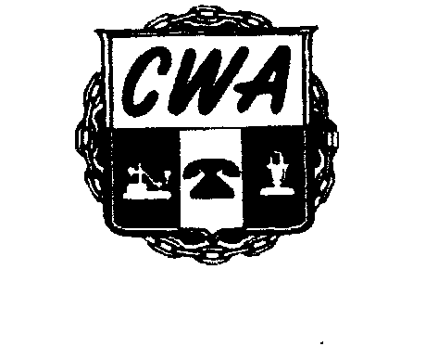
For CWA Local 3204 Union Members
UNION MEMBERS: Using one form per suggestion, please submit your 2015 Bargaining Suggestion by Friday, February 27, 2015. Please give specific examples to make your point

Completed forms can be faxed to Union Hall at 404-688-6236 or emailed to suggestions@cwa3204.org (Please use this format in the email.)

CONTRACT ARTICLE: ______6.04_______________ PAGE NUMBER: ___________91__________________

SUGGESTION: Add Article 6.04A6 to Read as follows: State of Emergency. If the a State of Emergency is declared
all employees in the affected jurisdiction will be excused from work with pay. Additional language can be added
to compensate employees at double time rate if the employee choose to come to work. But this should be the
choice of each employee.

REASON: In the years past many states have declared a State of Emergency to which our members have been
forced to loose pay, vacation, and in other cases stuck in cars enduring sever weather. Adding this language will
make life simple for our members to stay home without losing pay.

SPECIFICEXAMPLE: In 2014 the state of Georgia declared a State of Emergency twice and many of our Georgia
members loss pay or was forced to use their vacation to receive pay. Some of our members ended up stuck in traffic for hours and in some case days.

Please provide the information below. You may have to be contacted for clarification. Please print.
Submitted by: ____________________________________________Title:_____________________________________
Work Location/Department: _________________________________________________________________________

Best Contact Number: _____________________________PersonalEmail:_____________________________________

CWA LOCAL 3204 / 279 LOGAN STREET / ATLANTA, GEORGIA 30312 / 404-688-1256

